**Final project: Automatically defend from DoS and DDoS traffic flood attacks**

DoS and DDoS attacks are server attacks that designed to prevent client-to-server communication (denial of service). These attacks aim to both public and private sectors, and occur more and more frequently. In addition, lately the massive DDoS attacks are performing 100 Gigabits per second, and being more common than ever. These attacks are sowing fear among organizations and private server owners.

Our project deals with understanding and examining DoS and DDoS attacks, and what are the solutions for them. In particularly, we will discuss and handle with traffic flood attacks on web servers, and will try to develop our own software or algorithm to block or to give any immediately pragmatic solution.

Our main goal is to achieve our own development, which would automatically identify and analyze a traffic flood attack, defend the server from it, and in need - will block any IP or sub-net which the flood comes from.

Our main idea is to create a script with an algorithm which blocks unwanted traffic and runs on a CDN server, which all the packets that are intended to the server, passes through it.

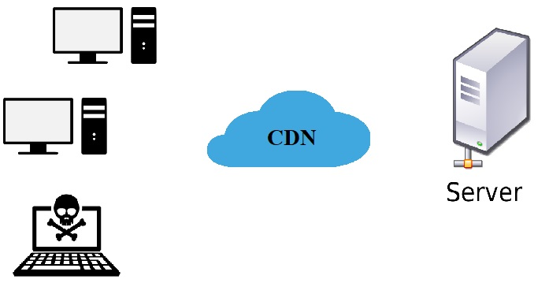

Advisor: Dr. Amit Dvir

Students:

Yinon Cohen 203526991

Maor Shabtay 305036162